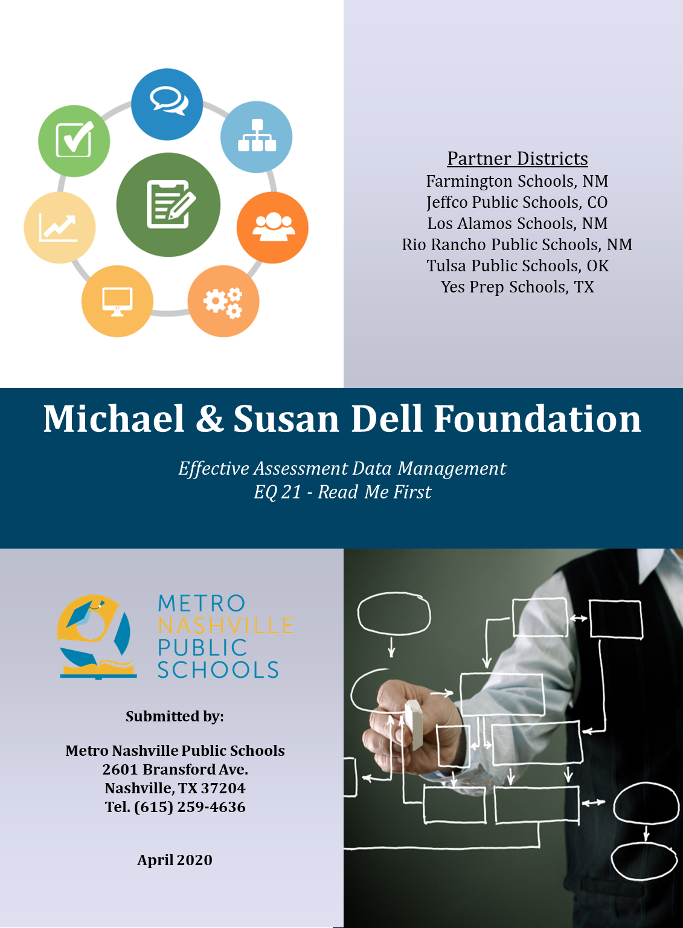

Effective Assessment Data Management (EADM) - Essential Question (EQ) 21 Documentation

The documents within this folder provide information required to design the EQ 21 visuals using the Ed-Fi ODS/API v3 on Microsoft SQL Server and SQL SRS (Server Reporting Services). The information ranges from design decisions to analytic guidelines. The intended audiences for these documents are education organization leaders in the areas of technology, data governance, and/or assessment.

This documentation intends to encourage and support the following structured process:
- Form a cross-functional work team with the knowledge of assessment, data (assessment, scheduling and course) and technology staff
- Adopt the EQ 21 and modify use case to accommodate your context, if needed
- Determine and catalog the analytic decisions for the visual
- Design the visual
- Identify assessment and sources systems for cross-assessment analysis
- Confirm the data mapping and the content for the visual
- Load the data
- Implement views for data access

The information is organized into both technical and functional manuals. Some manuals divided further into parts sections to address specific details.

Document | Description | Technical | Functional
Use Case | Describes a real-world example of how people or organizations interact with a process, situation or system. The basic strategy is to identify a scenario for the current and desired future state. |  | X
Mockup of visuals | Describes the how the data is displayed to answer the essential question |  | X
Lessons Learned | Describes knowledge or understanding gained by experience. | X | X
Technical Guide | Contains the SSRS code, along with the file of database structures and other documents required to produce the visual.  There are three rdl files for use by anyone with SQL Server installed. | X
Data Dictionary | Contains a set of information describing the contents, format, and structure of a database and the relationship between its elements, used to control access to and manipulation of the database. | X | X

The following education organizations worked collaboratively on the EADM project providing insight, suggestions, expertise, and guidance for the use case, analytics, and visualizations:
- Metro Nashville Public Schools, TN – Lead District
- Farmington Schools, NM – Partner District
- Jeffco Public Schools, CO – Partner District
- Los Alamos Schools, NM – Partner District
- Rio Rancho Public Schools, NM – Partner District
- Tulsa Public Schools, OK – Partner District
- Yes Prep Schools, TX - Partner District

Special thanks go to the members of Ed-Fi, who served as reviewers and experts in completing this work. Thank you to the Michael & Susan Dell Foundation for funding the EADM project.

